**SMART PARKING SYSTEM AND DETECTION OF UNAUTHORISED PARKING**

Sunny Rana1, Shahid Imran1, Shubham Mathur1

Gunjan Aggarwal2

1Student, 2Assistant Professor, Department of Computer Science & Engineering, SET, Sharda University, Greater Noida, India

**Abstract**

There has been a tremendous growth in the number of vehicles on road in past few years. But unfortunately the road networks and road widths have not grown in proportion to vehicle numbers. This has created in huge parking crisis especially in urban areas. At such times smart online parking systems are the need of the hour. This system aims at replacing the conventional parking system with an IoT-based smart parking system by using RFID (radio-frequency identification). The users will be provided an entry card for getting access to the parking slot. The users will also be provided with an android based mobile application, using which they can know about the availability of the parking slot on their mobile phones. Along with getting to know the real time availability of the parking slots the system also has the concept of detecting wrongly parked car within the parking area. In a parking area there are many areas which are either reserved or strictly no parking. Thus the system here also uses the concepts of RFID to get the car detected. In this way, this smart parking system will help reduce human effort & time by using automation technology.

KEYWORDS : RFID ,

**1. INTRODUCTION**

Now days due to drastic increase in the population, there has been a tremendous increase on the cars plying on the road. This has also put a pressure on these car getting proper parking. The existing parking management system includes extensive usage of man power and human intervention in order to provide the user with a proper parking. In this kind of system, a lot of time is wasted and the system is not quite effective and efficient. Along with this it has also been observed that in many parking areas the are some designated parking spots which are either reserved or are strictly marked as no parking, still some users park their cars in these spots which further increases the time, chaos and brings down the efficiency of the system. So, there is a need of developing an labour saving system that indicates directly the location of the parking spot along with all the necessary details of the parking via a mobile/web application. This system includes an RFID module, WIFI module, IR SENSORS that help in identifying and transmitting the information to the user. In areas where parking is prohibited a RFID receiver circuit is mounted. If a car is parked in an unauthorized area, the RFID detector detects the car and sends the notification message to the driver regarding the wrongly parked car.

**2. MATERIAL USED**

A. LIQUID CRYSTAL DISPLAYs (LCD)

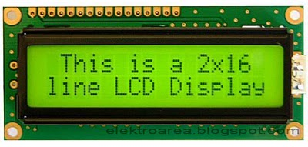

Figure.1 LCD display

The 20x2 and 16x2 displays are one of the most used LCDs that are integrated to the microcontrollers. This simply means 20 characters per line by 2 lines and 16 characters per line by 2 lines and, respectively. The standard is referred to as HD44780U, which communicates directly with the LCD and indicates to the controller chip which receives data from an external source.

B. RFID READER

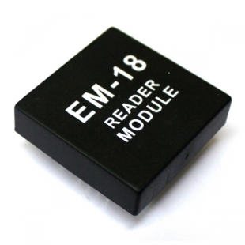

Figure.2 RFID module

From ID Innovations, this is a very simple to use RFID reader module. The only holdup is the 2mm pin spacing with a build in antenna. Powering up of the module, keeping up a card, and getting a serial string output containing the particular identity of the card.

C.GSM MODULE

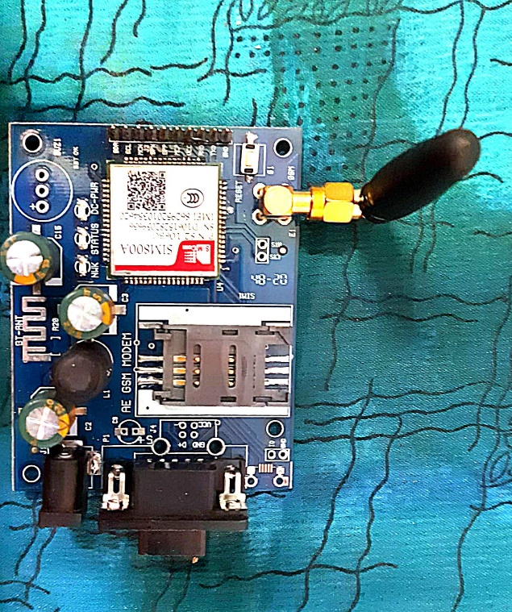

Figure.3 GSM module

SIM 800A is a Tri band GSM/GPRS engine that works on various frequencies like 900MHz, 1900MHz, and DCS 1800. With configuration of 40mmx33mmx2.9mm, SIM 800A can meet almost all the space requirements like in smart phone, PDA phone and other devices. The physical interface provides all hardware interfaces between the module and customers’ boards and the RF antenna that interfaces to the mobile application is a 60 pin board t board connector.

D. ATMEGA 328

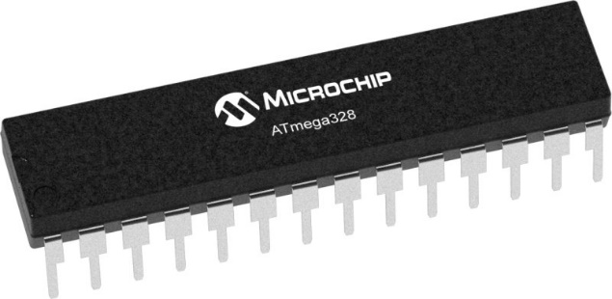

Figure .4 ATMEGA 328 MCU

The Atmel eight-bit AVR RISC-based totally microcontroller combines 32 KB ISP flash reminiscence with read-at the same time as-write talents, 1 KB EEPROM, 2 KB Static Random Access Memory, 23 widespread-reason I/O traces,32 general cause working registers.ATmega328 is normally used in many areas and [autonomous systems](https://en.wikipedia.org/wiki/Autonomous_systems) where a simple, low-powered, low-cost micro-controller is needed. Perhaps the most common implementation of this chip is on the popular [Arduino](https://en.wikipedia.org/wiki/Arduino) development platform, namely the [Arduino Uno](https://en.wikipedia.org/wiki/Arduino_Uno) and [Arduino Nano](https://en.wikipedia.org/wiki/Arduino_Nano) models.

E. DC MOTOR

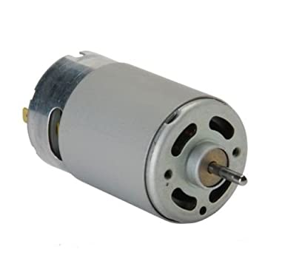

Figure.5 DC motor

A DC motor is one of the types of rotary [electrical motors](https://en.wikipedia.org/wiki/Electrical_motor) that converts direct current electrical energy into mechanical energy. The most common types rely on the forces produced by magnetic fields. DC motors use magnetic fields that occur from the electrical currents generated, which powers the movement of a rotor fixed within the output shaft. The output torque and speed depends upon both the electrical input and the design of the motor.

F. INFRARED SENSOR

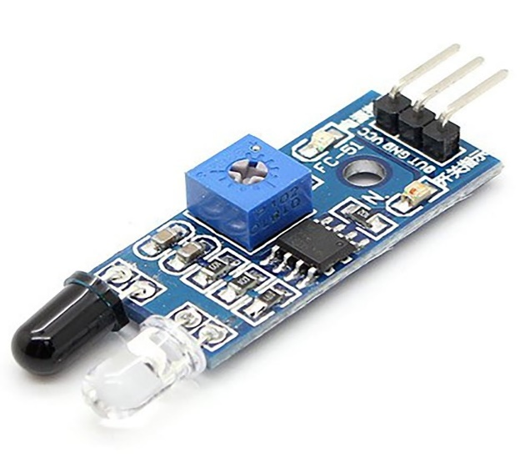

Figure .6 IR module

An infrared sensor is an electronic device, that emits in order to sense some aspects of the surroundings. An IR sensor can measure the heat of an object as well as detects the motion. These types of sensors measure only infrared radiation. Once the infrared transmitter generates emission, then it arrives at the object & some of the emission will reflect back toward the infrared receiver. The sensor output can be decided by the IR receiver depending on the intensity of the response.

G. ESP8266 WIFI MODULE

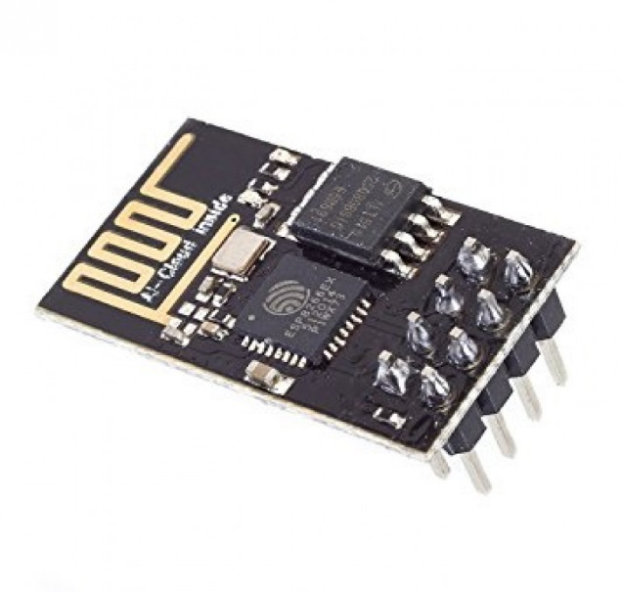

Figure .7 ESP8266 WIFI module

The ESP8266 MODULE is a low cost WIFI microchip, with built in TCP/IP networking software and microcontroller capabilities. This small module allows microcontrollers to connect to a WIFI network and make simple TCP/IP connection

**3. EXISTING SYSTEM**

The existing system for parking includes the efforts that the user has to make in order to get a correct parking slot. This system includes a lot of human efforts and involvement of people to allot a parking slot in a parking. In this system, the user has to manually identify a vacant parking slot and along with it there is no provision to detect any wrongly parked cars. Many a times it has been noticed and user’s are unaware of the vacant spots status and this leads to confusion, traffic jams and wastage of time. For the detection of wrongly parked cars, human efforts are required in the existing system. People are deployed to keep a check on the cars to avoid illegal parking in unauthorized area in order to avoid traffic jams and to have a smooth functioning of the cars. The disadvantage of the system is that it requires usage of extensive manpower and is slow in its working. Keeping all this in mind, there is a need to automate the parking system.

**4. PROPOSED SYSTEM**

Now days in many public places such as supermarkets, offices, hospital area, market areas and shopping malls there is a significant problem of car parking. This creates a problem for the people and as well as for the authority to handle the crowd and to get their cars appropriately parked. So, there is a need of developing a labour saving system that indicates directly the location and the details of a vacant car parking slot in a parking area. This system includes an IR sensor that detects whether a parking slot is vacant or not. If vacant, the user on entry gets to see a green colour parking slot on the screens placed in the parking area, where they can park their cars. The Esp8266 WIFI module helps the microcontroller to transmit the information procured by the IR sensors to the central system which in return displays and show real time monitored vacant parking slots on the screens placed in the parking area. The system also uses RFID tags to get the user information, there check in time/check out time and their balance in there RFID cards. The proposed system also has an additional feature to detect wrongly parked cars in an unauthorised area using the RFID transmitter that are placed in no parking areas within the parking. If a cars RFID tag comes in the range of such RFID transmitter, a message is send to the respective car owner about the wrongly parked car through SIM 800A GSM module. Then the owners are given a time of 10 mins to move their car otherwise a fine is imposed on there card. During the checkout, the system calculates the charges for the user based on their check in/check out time which also includes any fine that may have imposed due to wrong parking.

**5. LITERATURE SURVEY**

In the study [1] the author here made a system that helped drivers to locate and reserve a parking place online through accessing it on web platform. The study included usage if Arduino and concepts of RFID for the detection of the vacant spot, along with that there is usage of MYSQL for the database management. The system had a major drawback that it did not show the drivers the number of parking spaces available and did not allow the drivers to book a specific parking spot. [2] This study is based on the purpose to increase efficiency of the current parking system, track the nearest parking space available through the help of a router, and book the available parking space. The system uses ESP8266 controller and RFID modules, IR sensors for the detection of the vacant parking spots. This system did show the available number of parking spaces but did not send the reminder to the drivers a message to avail the parking spot. This system also did not have the facility to show the users live tracking of the parking spaces. [3] This study allows the user to access a web application/mobile application to book their parking spots in advance. This system uses Arduino board to detect vacant spots for parking and to interact with the cloud to share this information to the user via the mobile application. Through the application, the user can book the slot in advance prior to their visit. The system uses ARDUINO, GSM module, NODE MCU, servo motors and for the database it used MS SQL server. The disadvantage of this system is that with increase in the user number, the system tends to get slow. [4] This system provides with both mobile app and a website to book the parking slot. The user can book the slot prior and can pay for the parking using the in built payment feature that is made available in the application. The system uses IR sensors and NODE MCU for the detection of the vacant spot and to transfer the information received to their application. The system also provides with an option of cancelling the booking or to extend the stay time. One disadvantage that the system has is that the failure of IR sensors leads to the failure of the entire system. [5] The proposed system integrates RFID and WSN technologies to provide advanced features and services for car parking managements. It uses an active RFID tag per vehicle. The tag can be allocated to a subscribed customers over a long period of time (private parks), or it can be dynamically provided to the transient customers at the entrance. The system uses RFID module, servo motor, WSN application for the detection and allocation of the parking spot. The main advantage of the system is its low cost and simplicity over parking lot management. One disadvantage that the system has is that there is no driver guidance systems to guide the driver towards the parking spot. [6] This system includes the usage of Bluetooth, LCD (Liquid Crystal Display), ARM Cortex M3, Rack and pinion for its parking management. The system uses the user mobile’s Bluetooth for identification and registration. The vehicle is transported to the parking location with the help of a rack and pinion mechanism for linear motion. Then the system automatically detects the unique registration number stored in the Bluetooth chip to check if the new vehicle is to be parked or not. The advantage of the system is that it eliminates the need for additional parking tokens, as every Bluetooth has a unique registration number so the system is free from redundancy. Though the system is costly and the range of the Bluetooth causes range issues. [7] The system uses RFID module, Zigbee, WSN, MCU lPC2148 and led display. The sensor network carries all information about the parking space from the sensor node to management centre via Zigbee. This helps in the detection of the vacant parking slots and this information is further transmitted to the user through a mobile application. The system take more time during the node to node transfer of the information and its efficiency falls when the number of the users increase. [8] the author here studied about the system that consisted of RFID module, GSM modem, Infrared Sensor module, Servo motor, Arduino UNO, Arduino Mega. Here, it did not matter whether a vehicle had an RFID tag or not, as data of vehicles having no RFID tags will be verified in the particular RTO’S. The future scope involves fine and parking fee collection via e-payment and parking slot booking in advance via SMS. [9] It is based on 5 major processes Background Modelling, 1-D Projection, Segmentation, Tracking, Reconstruction. It presents a way for detecting the phenomena in real time by applying a novel image projection that reduces the dimension of the data and, thus, reduces the complexity of the segmentation and tracking processes.[10] In addition of detecting the vehicles which are falsely parked and imposing a fine on them this work allows us to book a parking slot in advance. It also presents the present number of cars, jeep, buses, and all other vehicles in the parking on the LCD. Future scope includes The Database has all the information stored related such as: type of the vehicle, model of the vehicle, registration number of the vehicle, the availability of space in the parking is also shown in the LCD. [11] It reads the vehicle id and checks whether its registered or not if it is registered then it further checks the database for the check-in time and opens the gate and updates the checkout info. If the vehicle is not registered the system will not open the gate. [12] This work checks whether a vehicle is parked at no parking area or not by reading RFID tag and if a vehicle is parked in that no parking area for more than 10 sec the buzzer will ring. If the vehicle is still there after the buzzer rang the particular information of the vehicle will be sent to the nearest police station and a fine will be imposed to the owner. [13] This work works on the principle that a RFID transmitter is fitted in no parking zone. whenever a car parks in the no parking zone the transmitter receives the signal and fines the driver. It has high accuracy, does real time monitoring and is easy to use. future scope may include sending the data of the driver to the authorities and doing online fine payments [14] The work works on the principle that a proximity sensor is fitted in the no parking area so as to detect the presence of any car. Along with it, a PIR sensor is also fitted to detect the presence of the driver. once the proximity sensor detects the car, it sends data to the nearby Sauthority. The work requires less human intervention and helps in clearing the congestion on roads. Its future scope includes capturing the image of the car and using inductive proximity sensor to detect metal.[15] The work is divided into 2 parts. first is the parking entry where through RFID the details of the driver and of the car are collected. second part includes the parking management system, it helps in detecting a vacant spot using an ultrasonic sensor and also uses ultrasonic sensors to detect wrongly parked cars. its future scope includes of expanding the work in small area of the city. [9] The work works on the principle that an IR sensor is fitted in the areas where parking is prohibited, if a car gets parked there, the system alerts the driver and gives them a timer of 5 mins, if even after 5 mins the car is not moved, the system fines the driver based on the information received through the RFID transmitter. in future the work aims to include the system to alert the authorities for further action.

**6. WORKFLOW DIAGRAM**

DDETECTION OF RFID

IF BALANCE < 0

DGATES DO NOT OPEN

SSYSTEM CHECKS THE BALANCE IN THE RFID CARD

HTHE VEHICLE GETS PARKED IN THE VACANT SPOT

IF BALANCE > 0

DDTHE GATES AUTOMATICALLY OPEN AND THE VEHICLE ENTERS

Figure 8. Workflow for entering the parking area

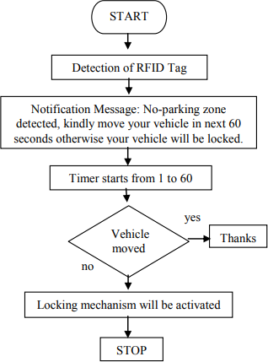

A message that the driver has been fined is sent to the driver

No fine is imposed

If the car is parked in a no parking zone, the RFID receiver detects the car and a message is sent to the driver about wrong parking

Figure .9 workflow diagram for detection of wrongly parked car

The system starts by the detecting a wrongly parked car through the RFID system, if the car is moved then no fine is imposed on the driver, but if the car remains parked in the no parking zone the system automatically fines the driver and a message is sent to the driver regarding the fine being imposed for the unauthorized parking

THE SENSOR TRANSMITS THIS INFORMATION AND THE MCU SHOWS THE SPOT AS FILLED

IF SLOT FILLED

DIR SENSOR DETECTS IF CAR IS PARKED IN FRONT OF IT OR NOT

IF SLOT EMPTY

THE IR SENSOR TRANSMITS THIS INFORMATION THROUGH THE ATMEGA MCU AND THE VACANT SLOT IS DISPLAYED ON THE SCREEN AND USER PARK THEIR CAR

Figure.10 Workflow diagram for the detection of vacant parking spots

The IR sensors detect whether a car is parked in front of them or not. through that the get the information regarding a vacant spot. Then this information is transmitted gathered by the ATMEGA MCU and is then transmitted through the WIFI module to the screens so as to notify the drivers regarding the availability of vacant spots

**7. METHODOLOGY**

**A) FOR THE PARKING**

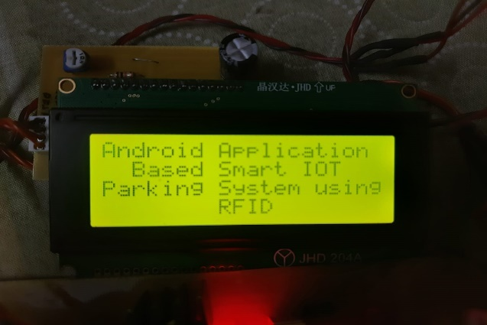

Figure 11. LCD display of the parking system

The system starts by the user first checking the status of the parking spots on the mobile/web application provided. Based on the status received through the system to the user, the user can identify whether any parking spot is vacant or not

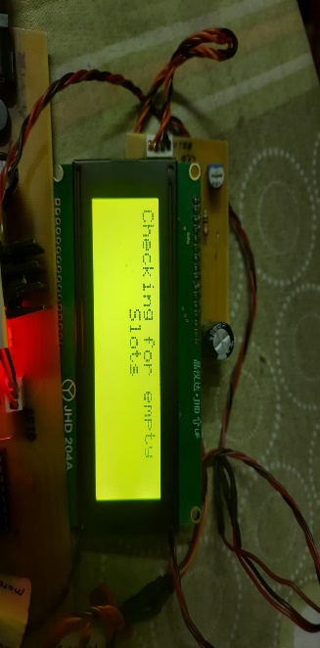

Figure 12. LCD checking for the empty slots in the parking

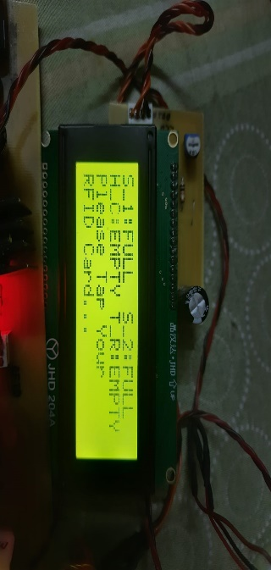

Figure 13. LCD displaying the status of the parking slots

The system through its IR sensors checks whether the parking spots are vacant or not. it then conveys the same information to the user using the mobile/web application. On reaching the parking lot, the system first scans the RFID tag to identify the user. Once identified, the system then checks the balance money present in the user’s RFID tag.

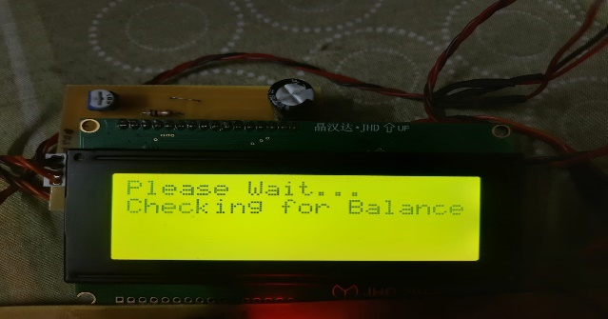

Figure 14. LCD displaying the balancing checking phase

If the amount is zero then the gates won’t open else the IR sensor detects the car and once the balance confirmation is received, the gates are automatically opened. Once the user entre the parking lot, their check in time is noted and the user parks the car in the allotted vacant spot. While exiting, the RFID tags present in the exit gates once again detect the user and determine their check out time. The system also checks if any penalty is also imposed on the user for the wrongly parked car. Through this their total time in the parking lot and their penalty is calculated and while exiting, the respective amount is automatically deducted from there RFID tag balance

**B) FOR THE DETECTION OF WRONGLY PARKED CAR**

The system starts with the user registering to the system for once through the GSM module. The user has to give a call to the sim number that is being used in the corresponding GSM module.

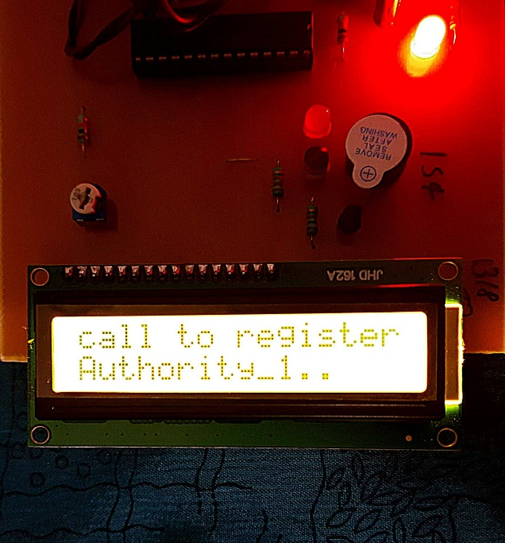

Figure 15. Screen showing calling message

Once the user has given the call, a unique RFID card is swiped that is unique to the user and it resembles the user itself. The system is having the capacity to handle two authorities at one time. Once a unique RFID card has been allotted to the user, a message is sent to the user stating ‘ you have been registered as authority 1’. Once both the authorities are registered and each have got a unique RFID card, the system then goes to the monitoring stage,

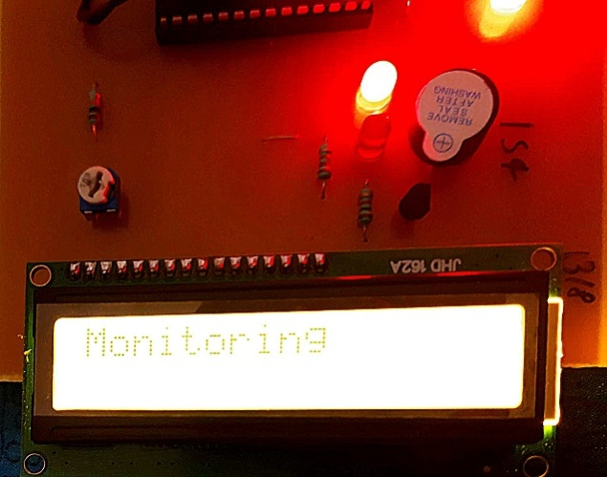

Figure 16. System in the Monitoring Phase

**8. RESULT**

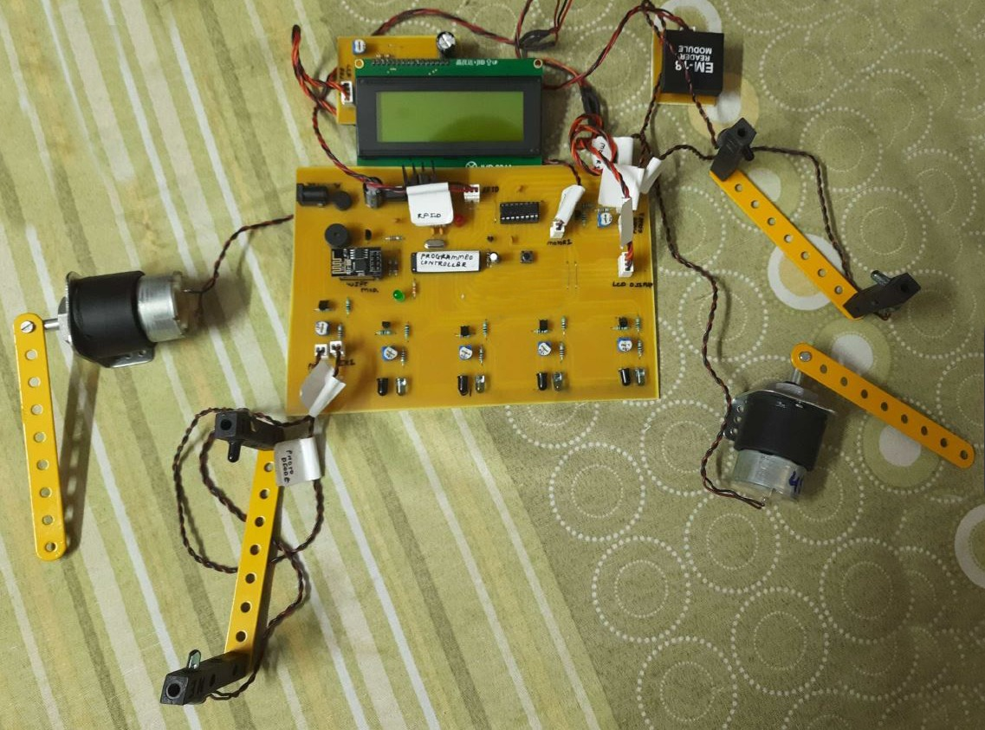

Figure 17. SETUP FOR THE PARKING MANAGEMENT SYSTEM

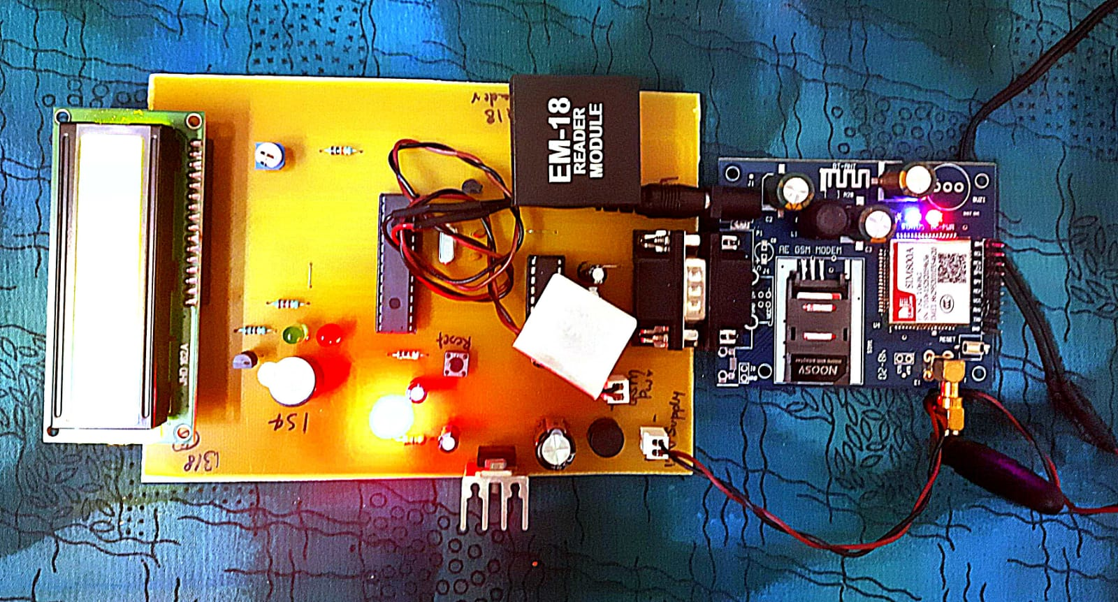

Figure 18. Setup of the Unauthorized Detection System

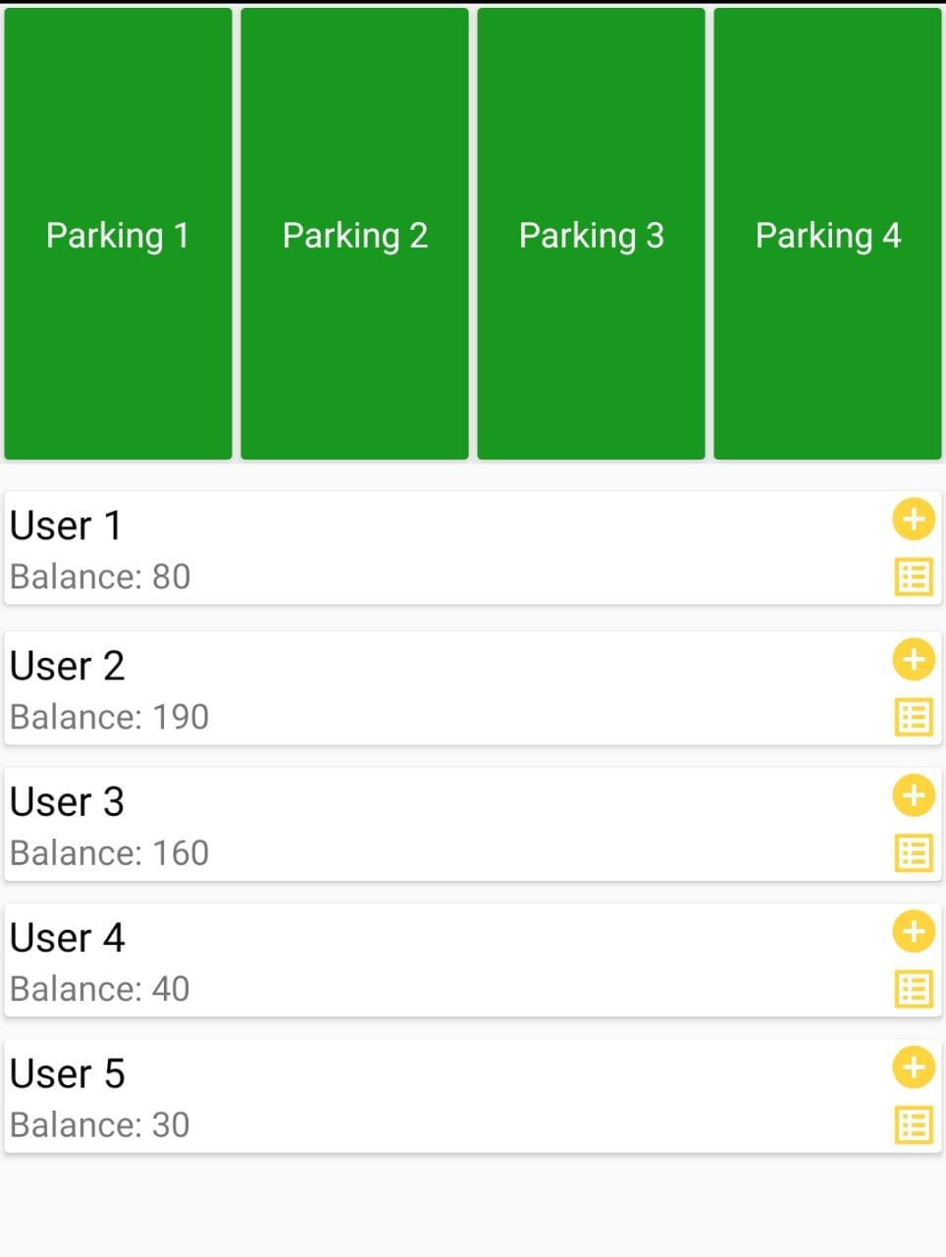

Figure 19. Application View Showing Vacant Parking Spots

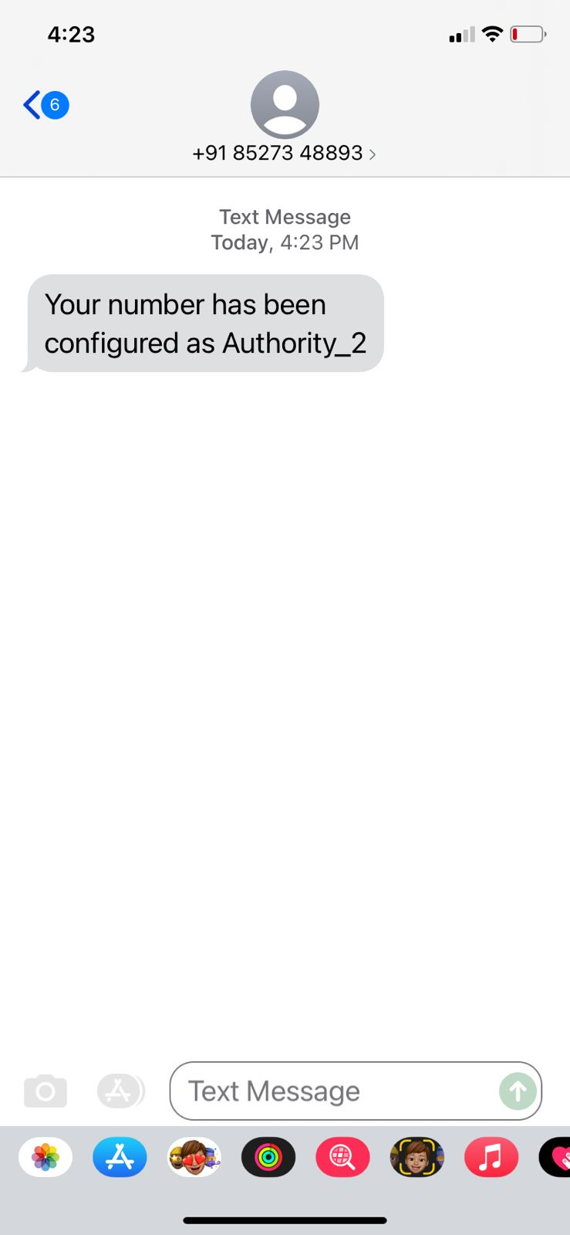

Figure 20. Message showing Successful Registration of the User

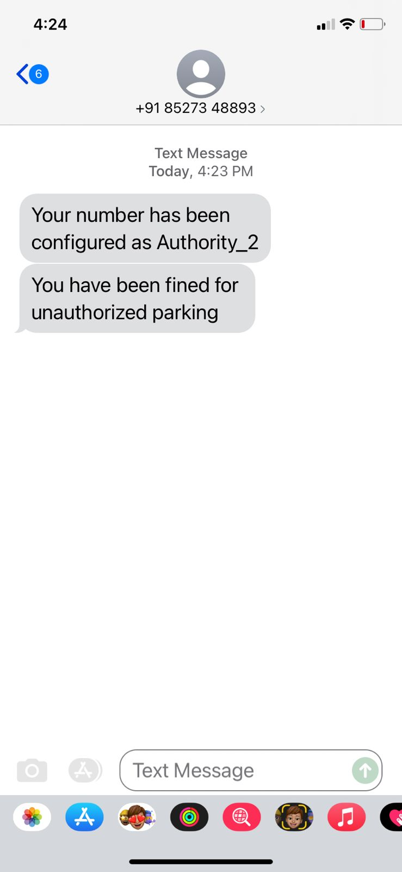

Figure 21. message showing authority 2 being fined for wrongly parked car

**9. CONCLUSION**

The system aims to reduce the issue of parking management and unauthorized parking using automatic techniques in order to reduce the human efforts and to improve the efficiency of the entire system using the modern technology. All these issues have been addressed by our proposed system that works with the aim to improve the conventional method adopted for the parking management and to tackle the issue of unauthorized parking in the parking lots. Through the system, regular monitoring can be achieved with minimum human intervention and more effective results can be obtained.

The system in the future may incorporate methods to cancel and extend the booking time for a particular parking spot. Along with this for the unauthorized parking, the system will include a buffer time of 10 mins for the driver to remove their car from the unauthorised parking and in future the range of the RFID module will be increased for more smooth functioning and increase in its efficiency

**10. REFERENCES**

[1] Ndayisaba Corneille , Rohit Diwakar, “ ONLINE VEHICLE PARKING RESERVATION SYSTEM”, IJESC, ISSN 2321-3361, VOL-10,ISSUE-5 , 2020

[2] Amol Pomaji, Suraj Boinwad, Shrikant Wankhede , Pushpendra Singh , Bhagyashree Dhakulkar, “Smart Parking Management System”, ISSN 2249-8958,VOL-8,ISSUE-5 JUNE 2019

[3] Amira. Elsonbaty and Mahmoud Shams, “SMART CAR PARKING MANAGEMENT SYSTEM USING RFID”, , IEEE AUG 2019

[4] Supreeth Y S, S G Raghavendra Prasad and Dr. Jitendranath Mungara, “Smart Parking System for Smart Cities”, IEEE XPLORE

[5] El Mouatezbillah Karbab, Djamel Djenouri, SaharBoulkabol, Antoine Bagula, “Car Park Management with Networked Wireless Sensors and Active RFID”, ISN : 2320-8945 , VOL 1 , ISSUE-2,2013

[6] Harmeet Singh, Chetan Anand, Vinay Kumar, Ankit Sharma, “Automated Parking System with Bluetooth access”, , IJARSE VOL-7, APR 2018

[7] M. M. Rashid, A. Musa, M. AtaurRahman, N. Farahana, “Automatic Parking Management System and Parking Fee Collection Based on Number Plate Recognition”, 9th International (pp. 639-643). IEEE.2015

[8] Manjusha Patil, Vasant N. Bhonge, “Wireless Sensor Network and RFID for Smart Parking System”, IJEAT,ISSN-22498958 VOL-9 ,ISSUE-2, DEC 2019

[9] Ishraq Haider Chowdhury, AfsanaAbida, Md. Mehedi Hasan Muaz Automated Vehicle Parking System And Unauthorized Parking Detector

[10] Jong T. Lee, M. S. Ryoo, Matthew Riley, J. K. Aggarwal Real-Time Illegal Parking Detection in Outdoor Environments , IEEE AUG 2019

[11] S. C. Hanche, Pooja Munot, PranaliBagal, Kirti Sonawane& Pooja Pise Automated Vehicle Parking System using RFID , ISN : 2320-8945 , VOL 1 , ISSUE-2,2013

[12] ZeydinPALA , Nihat inanSMART PARKING APPLICATION USING RFID , IEEE XPLORE

[13] Murthy D. A ,Manjunath A ,MadhusudhanP,WarshaBalani , DESIGN AND DEVELOPMENT OF NO PARKING SYSTEM , IJARSE VOL-7, APR 2018

[14] C. George Christopher, J. Vidhya Unauthorized Vehicle Parking Detection and Auto-Locking using an Arduino, IJEAT,ISSN-22498958 VOL-9 ,ISSUE-2, DEC 2019

[15] M Manoj Prabhu, R Jayaraj, R Karthikeyan Automatic Unauthorized Parking Detector

IJEAT , ISSN 2249-8958,VOL-8,ISSUE-5 JUNE 2019

[16] Ankita Gupta, Ankit Srivastava, Rohit Anand Smart vehicle parking monitoring system using RFID

IJITEEE , ISSN 2278-3075, VOL-8, ISSUE-9,JULY 2019

[17] M.Indumathy , A. Arun Reddy , K. Jitender Reddy Avoidance of unauthorised vehicle parking IJESC, ISSN 2321-3361, VOL-10,ISSUE-5 , 2020

[18] J. Cynthia, C. B. IOT based Smart Parking Management System. International Journal of Recent Technology and Engineering (IJRTE), 2018

[19] Asghar Ali Shah, G. M,. Video Stitching with Localized 360 Model for Intelligent Car Parking Monitoring and Assistance System . IJCSNS International Journal of Computer Science and Network Security.2019

[20] Rico, J., Sancho, J., Cendon, B., & Camus, M. Parking easier by using context information of a smart city: Enabling fast search and management of parking resources. In Advanced Information Networking and Applications Workshops (WAINA), 2013 27th International Conference on (pp. 1380-1385). IEEE. 2018

[21] Ji, Z., Ganchev, I., O'droma, M., & Zhang, X. A cloud based intelligent car parking services for smart cities. In General Assembly and Scientific Symposium (URSI GASS), XXXIth URSI (pp. 1-4). IEEE.2014

[22] Chen, S. Y., Lai, C. F., Huang, Y. M., & Jeng, Y. L. Intelligent home-appliance recognition over IoT cloud network. In Wireless Communications and Mobile Computing Conference (IWCMC), 9th International (pp. 639-643). IEEE.2015

[23] R. H. Giva Andriana, Anak Agung, “Sensor Comparation for Smart Parking System,” pp. 4–9, 2012.

[24] S. A. El-seoud, H. El-sofany, and I. Taj-eddine, “Towards the Development of Smart Parking System using Arduino and Web Technologies,” no. 978, pp. 10–16, 2016.